NAME: | PARVENDHAN C
ROLL NO: | 241801197
DEPT: | AI&DS
- Create a simple view called view_d_songs that contains the ID, title and artist from the DJs on Demand table for each “New Age” type code. In the subquery, use the alias “Song Title” for the title column.
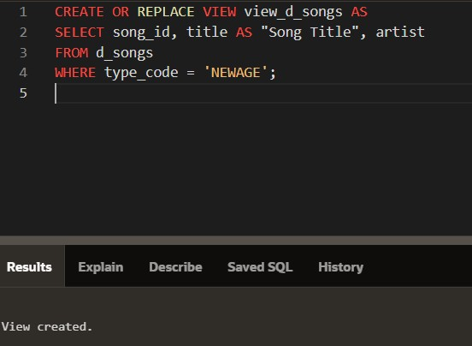
- SELECT * FROM view_d_songs. What was returned?
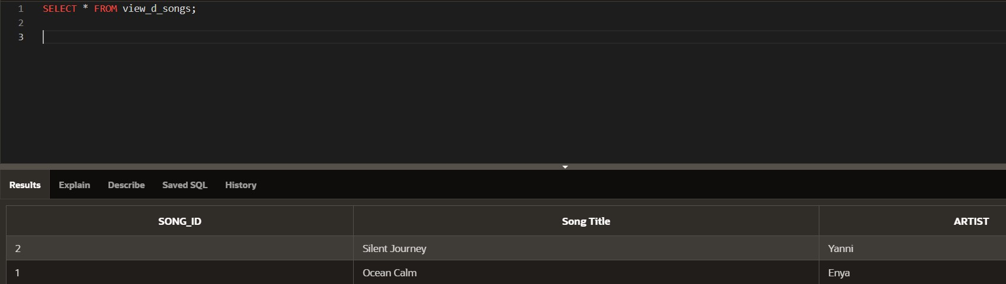
- REPLACE view_d_songs. Add type_code to the column list. Use aliases for all columns. Or use alias after the CREATE statement as shown.
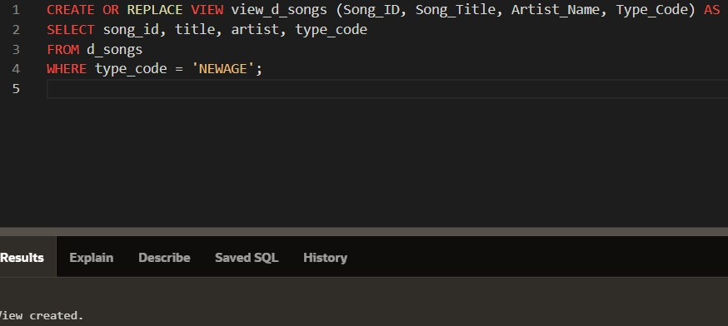
- Jason Tsang, the disk jockey for DJs on Demand, needs a list of the past events and those planned for the coming months so he can make arrangements for each event’s equipment setup. As the company manager, you do not want him to have access to the price that clients paid for their events. Create a view for Jason to use that displays the name of the event, the event date, and the theme description. Use aliases for each column name.
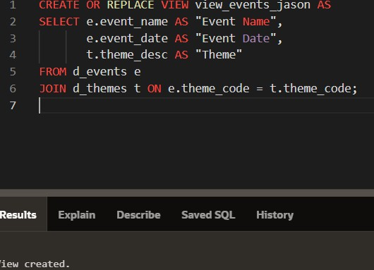
- It is company policy that only upper-level management be allowed access to individual employee salaries. The department managers, however, need to know the minimum, maximum, and average salaries, grouped by department. Use the Oracle database to prepare a view that displays the needed information for department managers.
